4.1 names and formulae
name: class: due date:9.23
1. Iron can react with sulfur to form two ionic compounds.
The iron is present as Fe²⁺ in one compound and as Fe³⁺ in the other compound.
The sulfur ion is present as S²⁻ in both compounds.
What are the formulae of the two compounds? （ ）
A FeS and Fe₂S₃
B FeS and Fe₃S₂
C FeS₂ and Fe₃S₂
D FeS₂ and Fe₂S₃

2. Iron(III) chromate is a yellow solid. It contains the ions Fe³⁺ and CrO₄²⁻.
What is the formula of iron(III) chromate? （ ）
A FeCrO₄ B Fe₃(CrO₄)₂ C Fe₂CrO₄ D Fe₂(CrO₄)₃

3. The formulae of compounds W, X and Y are shown.
W CuSO₄.5H₂O
X MgSO₄.7H₂O
Y Cu(NO₃)₂.6H₂O
Which statement is correct? （ ）
A W contains twice as many hydrogen atoms as oxygen atoms.
B X contains the most oxygen atoms.
C Y contains the most hydrogen atoms.
D Y contains the same number of hydrogen and oxygen atoms.

4. The table shows the numbers of atoms present in the formula of some compounds.
Which row is not correct? （ ）
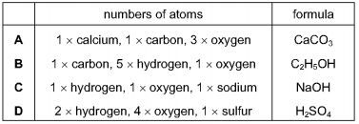

5. The formulae of some ions are shown.
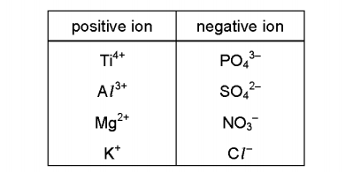
Which formula is not correct? （ ）
A Al₃(SO₄)₂ B K₃PO₄ C Mg(NO₃)₂ D TiCl₄
6. A compound contains one atom of calcium, two atoms of hydrogen and two atoms of oxygen.
What is the correct chemical formula of the compound? （ ）
A CaO₂H₂ B HOCaOH C H₂CaO₂ D Ca(OH)₂

7. Name the compounds containing only these elements:
a sodium and fluorine
b fluorine and hydrogen
c sulfur and hydrogen
d bromine and beryllium

8. Deduce the formula: a b
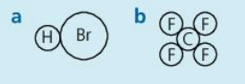
9. Is the formula correct? If not, write it correctly.
a HBr₂ b NaF₂ c MgO₂ d CaCl₂ e Be₂O
A. B. C.
D. E.
10. Give the formula for:
a barium iodide
b hydrogenoxide
11. Suggest a name and formula for a compound that
forms when phosphorus reacts with chlorine.
Name:
formula:
12. The formula for silicon(IV) oxide is SiO₂. Why?

